**Douglas Tompkins, co-founder of North Face, dies in kayak accident**

[San Francisco ChronicleSan Francisco Chronicle](http://sfgate.com/)

[San Francisco Chronicle](http://sfgate.com/)

By Peter Fimrite5 days ago

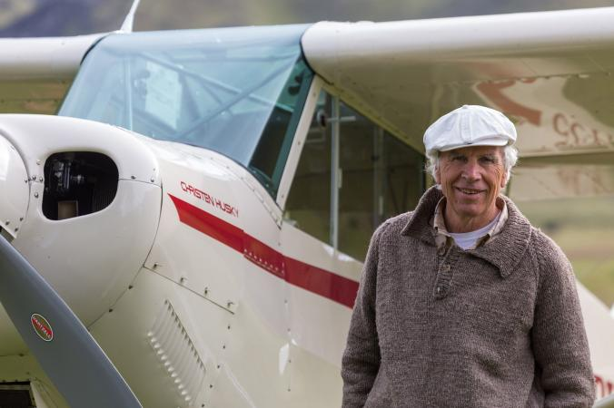

Douglas Tompkins, an outdoorsman, environmental activist, conservationist and entrepreneur who co-founded the North Face clothing company in San Francisco, died Tuesday in a kayaking accident in southern Chile.

Mr. Tompkins, who also co-founded Esprit with his then-wife, Susie Tompkins Buell, capsized while paddling with five other people on General Carrera Lake in the Patagonia region, according to reports confirmed by North Face officials. He was eventually pulled from the water, but died of hypothermia at Coyhaique Regional Hospital. He was 72.

General Carrera is a picturesque lake surrounded by snow-capped peaks in the Andes. It is known for spectacular geological formations, unpredictable weather and cold water, generally below 40 degrees Fahrenheit.

Mr. Tompkins, an experienced kayaker, and his fellow paddlers capsized after being hit by large waves in bad weather, according to reports from the Chilean army. A military patrol boat rescued three of the boaters, and a helicopter lifted out the other three, according to the army.

South American news stations reported that Mr. Tompkins was in the water for a lengthy period before he was rescued.

Mr. Tompkins was born in Ohio in 1943 and grew up in Millbrook, N.Y. A ski racer, rock climber and alpinist with several first ascents to his credit, he founded the California Mountaineering Guide Service in 1963. He co-founded North Face in 1964. The retail store — named after the coldest, most unforgiving side of a mountain — was founded in North Beach as a way to equip mountaineers, explorers and climbers. It still sells high-performance climbing and backpacking equipment.

Mr. Tompkins was described as an adventurer and risk taker who employed his brilliant imagination both in business and in trying to save the Earth. He met his first wife, Tompkins Buell, while hitchhiking. The two had two daughters and co-founded the Esprit clothing company. By 1986, Esprit had grown into a global brand, hitting $800 million in sales. They divorced in 1989.

“I’m incredibly saddened by this, but he lived on the edge,” said Tompkins Buell, who remained close to her ex-husband. “He used to come home from adventures and say, ‘Well, I cheated death again.’ That’s the way he lived. He was a very inspired person. There wasn’t anything he thought he wanted to do that he didn’t do.”

His daughter, Quincey Tompkins Imhoff, of Healdsburg, remembered a time as a girl when her father landed a small plane on a remote beach in Baja California only to notice later that the tide was rolling in and covering the wheels. She, her sister and the other passengers were told to sit on the tail wing to give the plane traction and then jump off as the plane caught air.

“He flew off and there we were on the beach,” she said. “He flew back about an hour later and dropped off a backpack with a sleeping bag, some snacks and a note that said, ‘I can’t land till low tide, write me messages in the sand that I can read from the air.’

“We spent all day there thinking we were doomed,” Tompkins Imhoff said. “Soon enough, he came back and landed and everything was fine. That was my dad in a nutshell. There weren’t too many dull moments.”

Mr. Tompkins had first visited Chile in 1961 and frequently returned to climb, ski, kayak and hike. After his divorce, he climbed Mount Fitz Roy in Patagonia, an experience that he said helped inspire him to become an environmental activist in the area.

He and his second wife, Kris Tompkins, whom he married in 1993, bought more than 2 million acres of wilderness in Chile and Argentina and devoted themselves to creating parks, protecting wildlife and supporting ecologically sustainable agriculture.

In 1991, Mr. Tompkins bought the 42,000-acre Reñihué Farm and founded the Pumalín Project, dedicated to the protection of the land’s primeval native rain forest, which was being threatened by logging.

“I’ve never come in personal contact with anybody who could think so big,” said Tompkins Imhoff. “He had the ability to walk his talk. and the mark he left in terms of conservation and vision will live on. He used to always tell me, ‘Don’t let your imagination get in the way of your potential.’ He is gone, but he will not be forgotten.”

Besides his wife and daughter, he is survived by his mother Faith Tompkins and brother John Tompkins, both of Millbrook, N.Y.; daughter Summer Tompkins Walker of San Francisco; and five grandchildren.

*Peter Fimrite is a San Francisco Chronicle staff writer. E-mail:* [*pfimrite@sfchronicle.com*](mailto:pfimrite@sfchronicle.com)

***One comment:*** *_____________________________________________________________________________________*

*_____________________________________________________________________________________*

***One Question:*** *(Use Bloom Taxonomy)*

*______________________________________________________________________________________*

*_______________________________________________________________________________________*